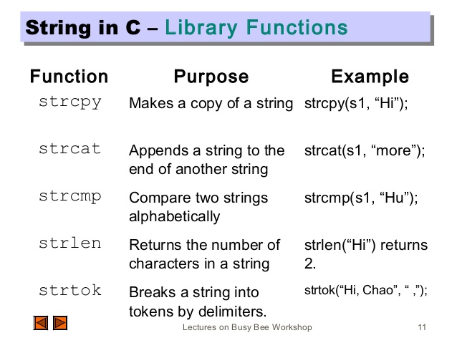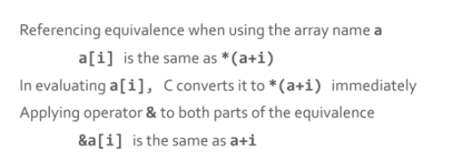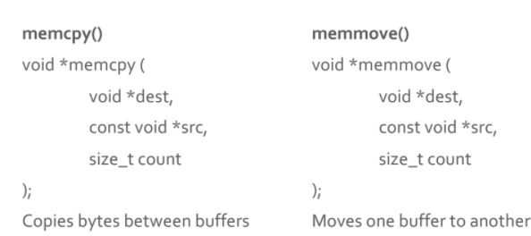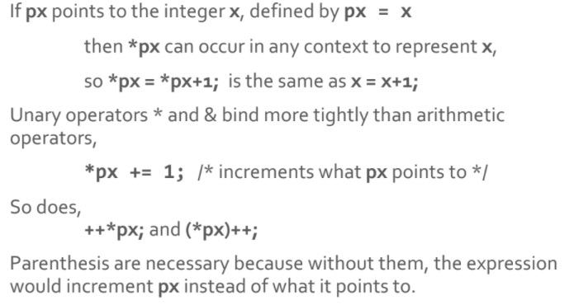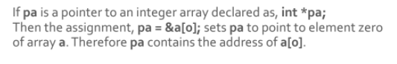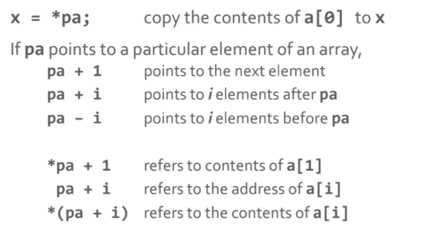 \

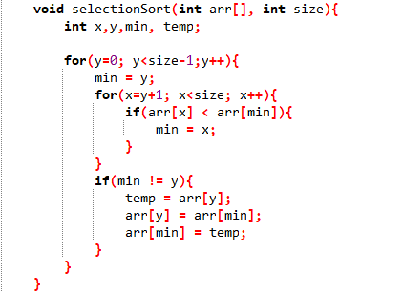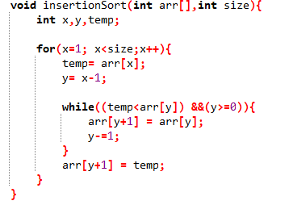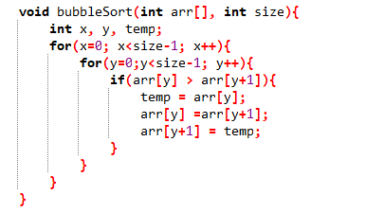

|  |
| --- |
| [int isalnum(int c)](https://www.tutorialspoint.com/c_standard_library/c_function_isalnum.htm)  This function checks whether the passed character is alphanumeric. |
| [int isalpha(int c)](https://www.tutorialspoint.com/c_standard_library/c_function_isalpha.htm)  This function checks whether the passed character is alphabetic. |
| [int isdigit(int c)](https://www.tutorialspoint.com/c_standard_library/c_function_isdigit.htm)  This function checks whether the passed character is decimal digit. |
| [int islower(int c)](https://www.tutorialspoint.com/c_standard_library/c_function_islower.htm)  This function checks whether the passed character is lowercase letter. |
| [int ispunct(int c)](https://www.tutorialspoint.com/c_standard_library/c_function_ispunct.htm)  This function checks whether the passed character is a punctuation character. |
| [int isspace(int c)](https://www.tutorialspoint.com/c_standard_library/c_function_isspace.htm)  This function checks whether the passed character is white-space. |
| [int isupper(int c)](https://www.tutorialspoint.com/c_standard_library/c_function_isupper.htm)  This function checks whether the passed character is an uppercase letter. |
| int tolower(int c)  This function converts uppercase letters to lowercase. |
| int toupper(int c)  This function converts lowercase letters to uppercase. |

